**iPinyouID Top 100 Records – Module 2**

**MapReduce**

* Data processing layer in Hadoop.
* Processing structured & Unstructured Data in Hadoop.

**Pros**

* Best Performance

**Cons**

* Hard to Extend
* Lack of management tools
* Not suitable for real time processing
* very small community

**Input Directory**

Input directory contains input files that will be processed by MapReduce to get Top-100 records on the basis of count amount of records for each *iPinyouID*.

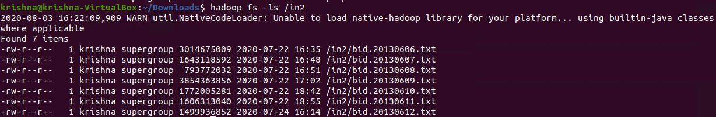

In the above screenshot, we can see an input directory (in) contains 7 input files :

1. bid.20130606.txt
2. bid.20130607.txt
3. bid.20130608.txt
4. bid.20130609.txt
5. bid.20130610.txt
6. bid.20130611.txt
7. bid.20130612.txt

**bid.20130606.txt**

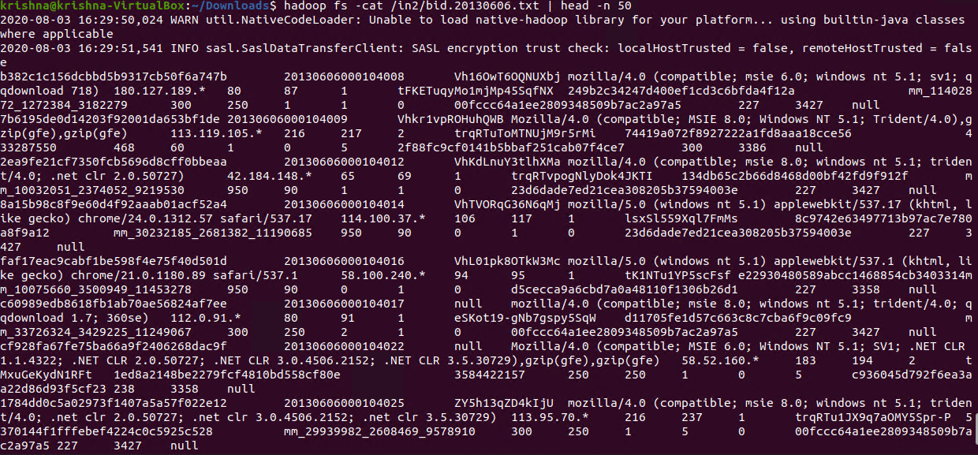

In the above screenshot, we can see the content of the input file.

**Executing Hadoop Jar**

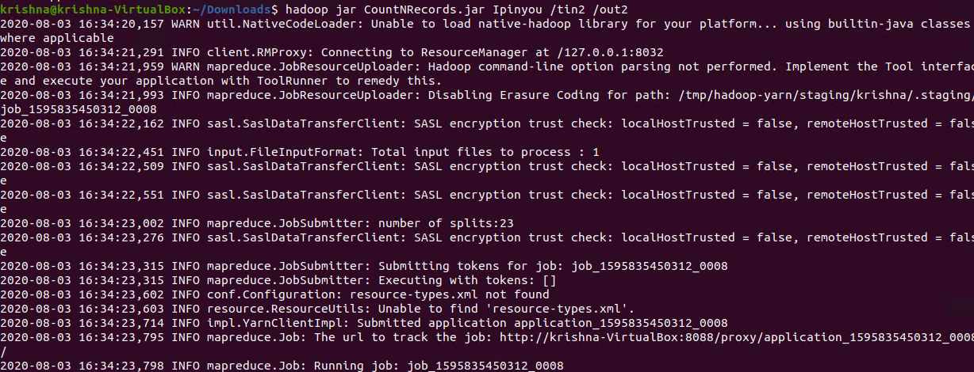

In the above screenshot, we can see the command to to get Top-100 records on the basis of count amount of records for each *iPinyouID*.

**hadoop jar:** This is command used to execute Hadoop jar

**CountNRecords.jar:** Hadoop jar file name

**CountNRecords:** jar class name contains main().

**/in:** Input directory contains file to process

**/out:** Ouput directory will be created after execution of this command

**Output Directory**

Output directory will be automatically created contains output files.



**Read output file Content:**

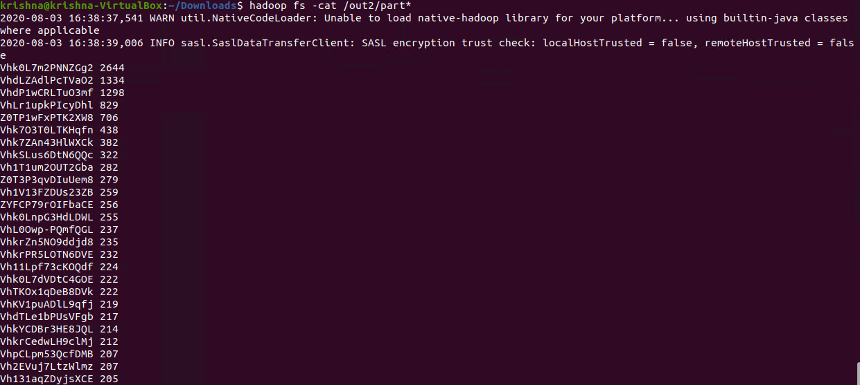

In the above screenshot, we can see the output contains Top-100 records.

**Test Cases:**

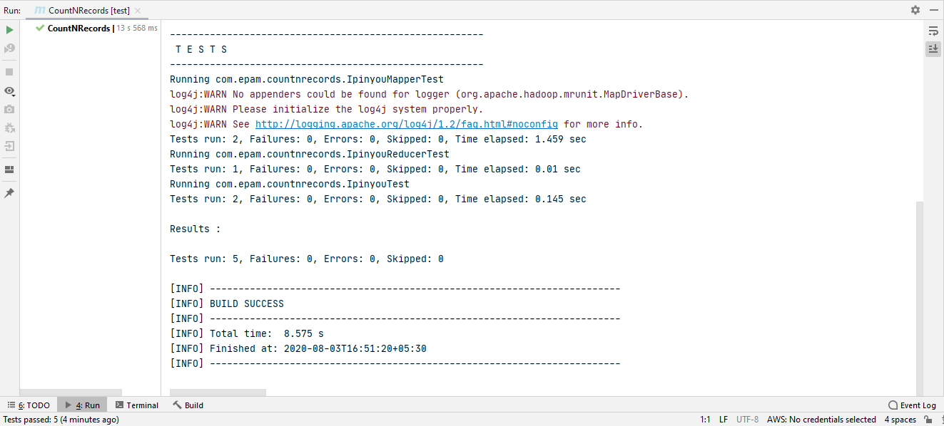

In the above screenshot, we can see that all 5 test cases have passed.